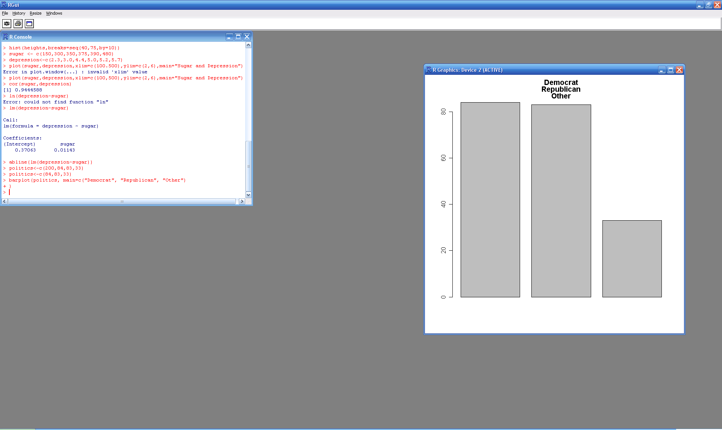

> politics

[1] 84 83 33

>barplot(politics, main=c("Democrat", "Republican", "Other"))

pie(politics, main=c("Democrat", "Republican", "Other"))

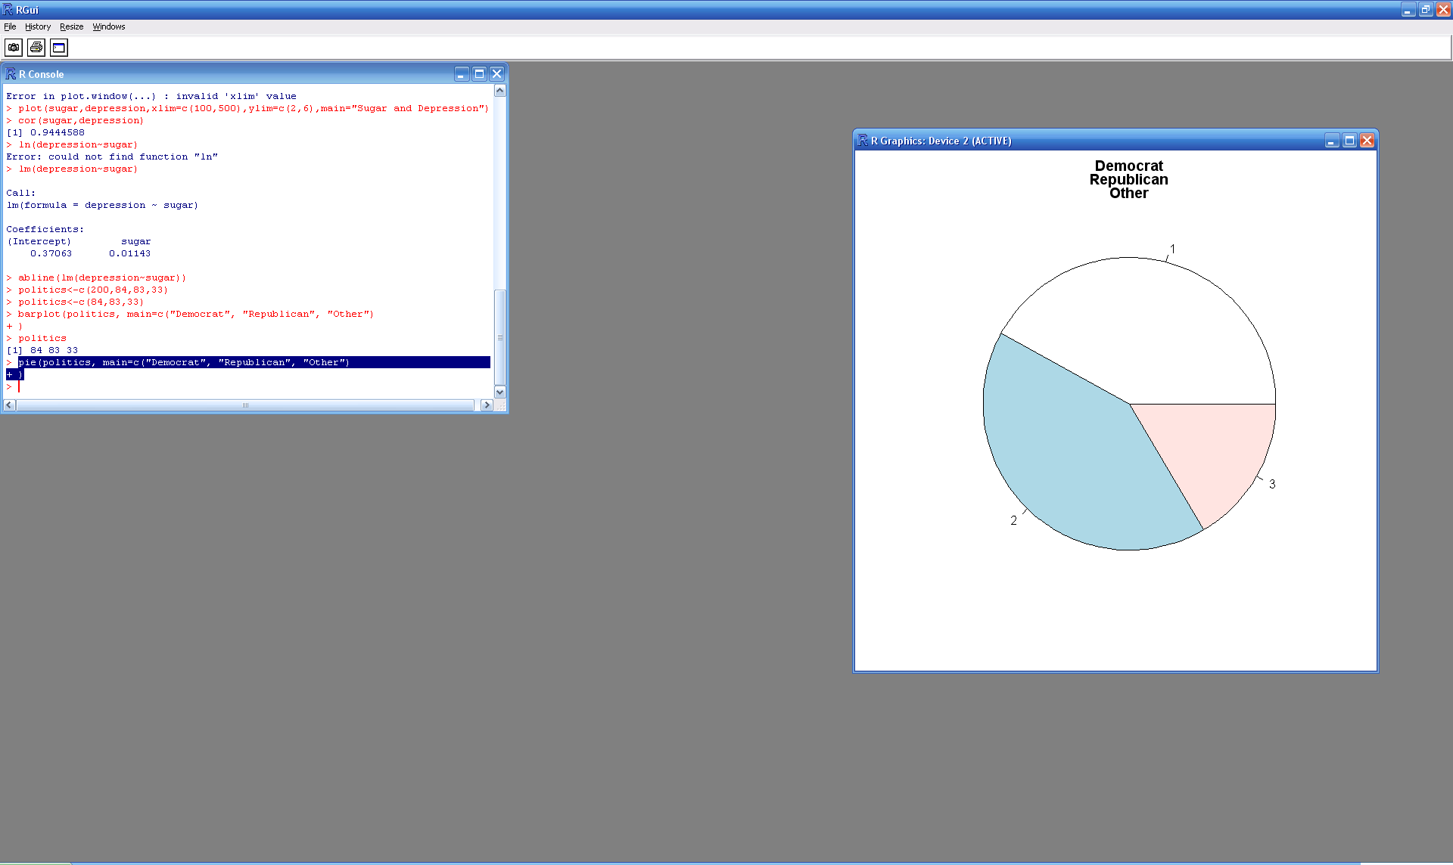

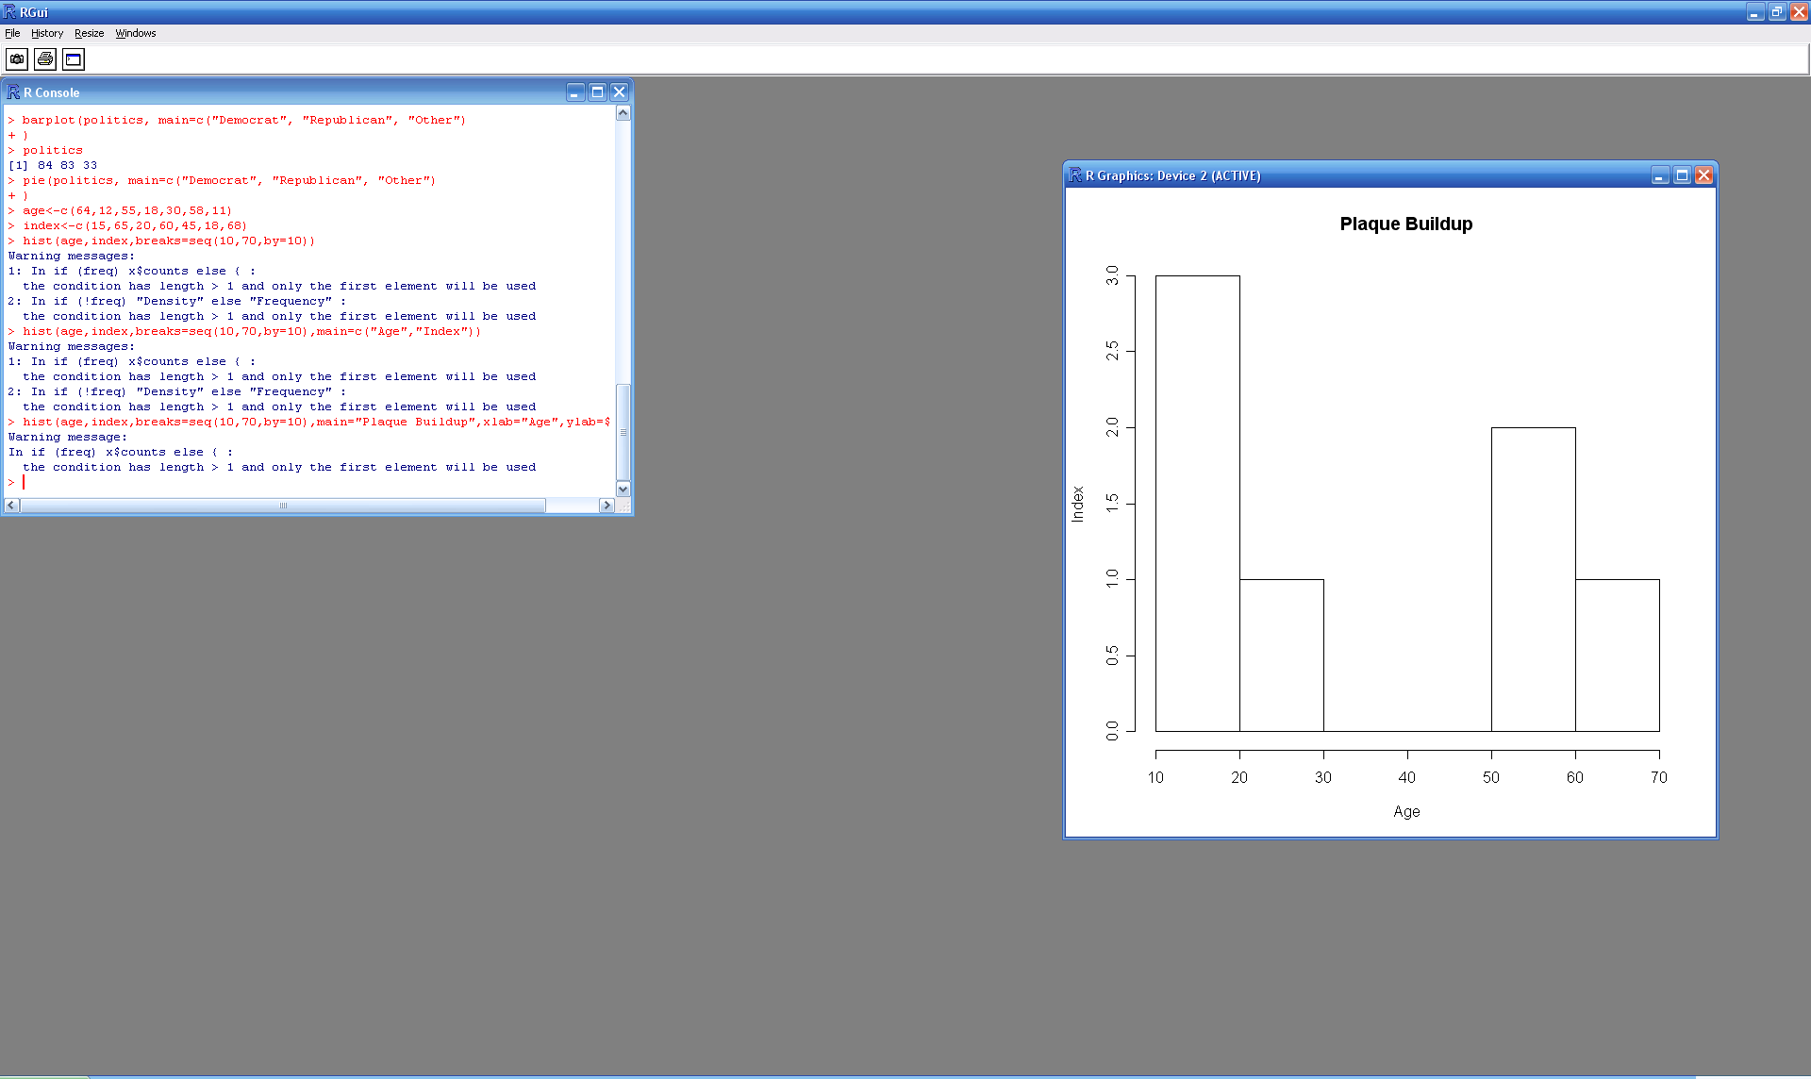

hist(age,index,breaks=seq(10,70,by=10),main="Plaque Buildup",xlab="Age",ylab="Index")

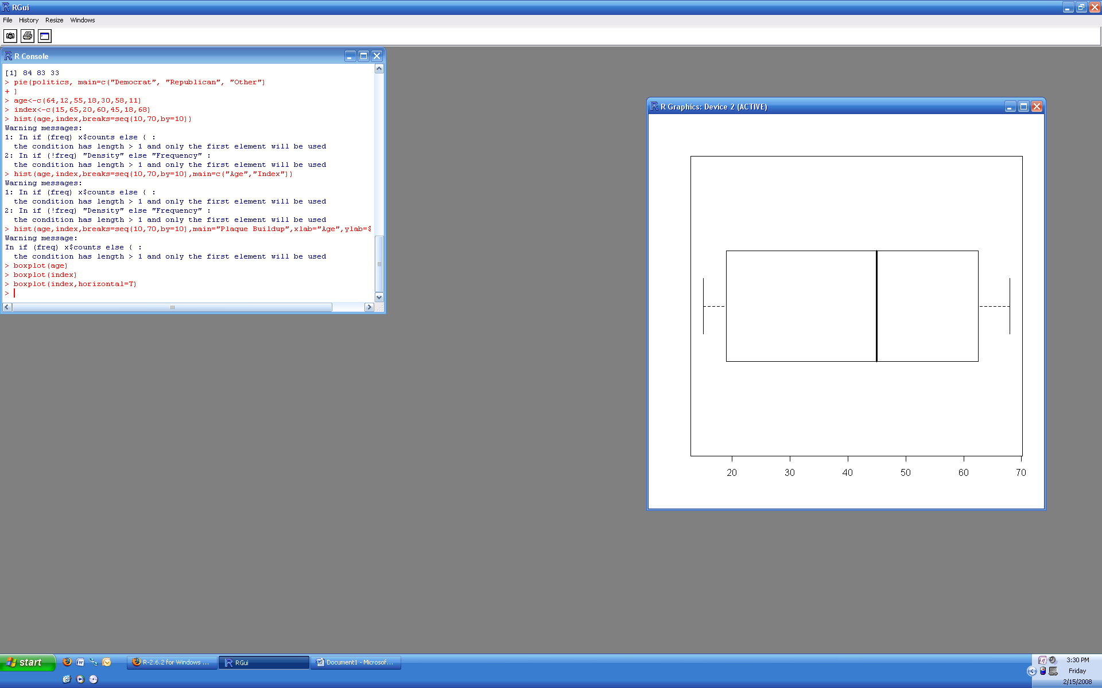

boxplot(index,horizontal=T)

stem(index)

The decimal point is 1 digit(s) to the right of the |

0 | 58

2 | 0

4 | 5

6 | 058

> plot(age,index,main="Plaque Buildup",xlab="Age",ylab="Index")

> abline(lm(age~index))

> cor(age,index)

[1] -0.9974604

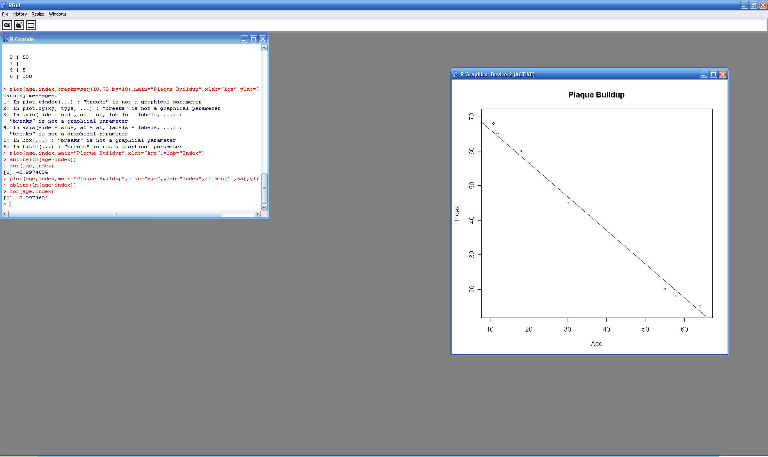

lm(formula = index ~ age)

Coefficients:

(Intercept) age

77.667 -1.019